Emax-ABAP- Day 5: 13-03-2026- Virtual Data model:
Content:
Virtual Data Model
Virtual fields(Calculation fields)
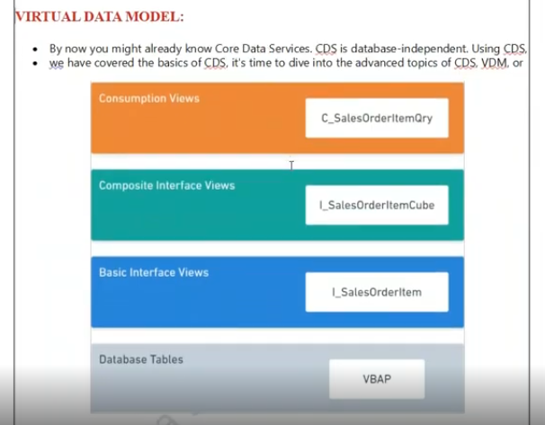
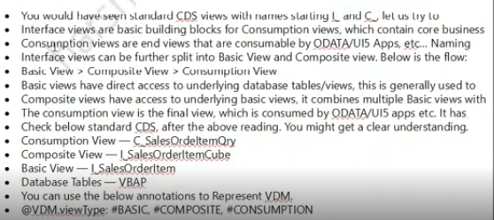
In CDS –
Layer – where can I consume the set of logic/ Where can I go for complex logic/ Where can I expose the CDS in Fiori/UI level.
In RAP also this is the very much needed..
Before coming to that- these layers applicable for standard cds view which is sap has built it ? answer is yes- SAP also implemented same procedure at the time of implementation.
1st layer : Interface View:
- All the standard CDS views, will be start from I_* - means this is the interface view.
- If you are creating the custom CDS View/ custom interface view we have to go with naming convention -ZI_*
- Basic interface view- Don’t keep the too much complex logic. It should be keep it as simple.
- This is interface will be created based on exist database table or existing CDS view also.
- Ex: if I want to get the header data and I want to joining condition on sales order item, for that this joining condition don’t keep it in interface view. Keep the interface view only for data retrieval. Whatever your complexity logics are there, we can keep those into the composite views.
Layer-2- Composite views.
- This composite view contains all the complex logic has involved ( like all the join condition/ associations)
- How the composite view will be created?- composite view will be created on based on interface view.- whatever interface view will created so composite view is created based on those interface views/ CDS VIEWS/Tables.
- How come this cds view identified – this is the basic view/ this is the composite view.? For this we have the annotation:
@VDM.viewType: #BASIC/#COMOSITE/#CONSUMPTION
3rd Layer: Consumption:
- Consumption View is the final view.
- Here don’t consume the any piece of the logic .
- Keep you consumption view only to be explored the odata/Apply ui annotations.
- OData annotations: @Odata.publish : true
- 15: 00

Create CDS Views:
CDS view name: ZI_SD_HDR
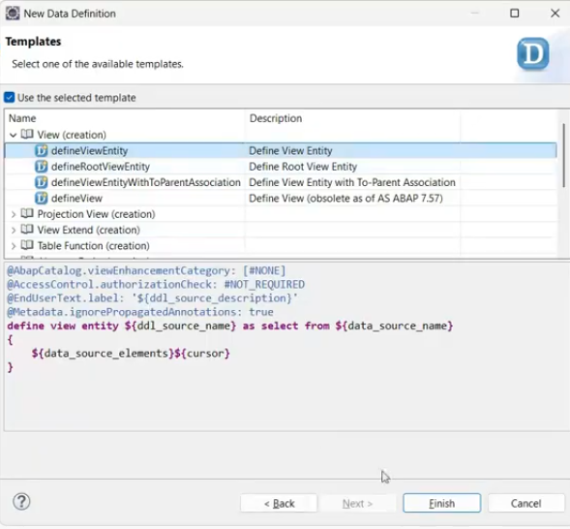
Keep interface view simple data retrieval
@VDM- data model - #BASIC
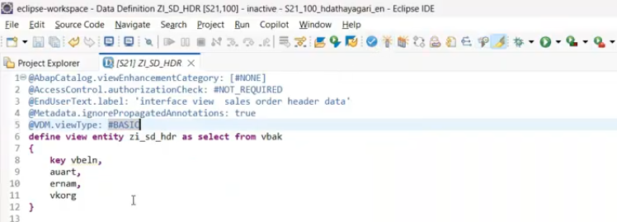
Once you create the BASIC view – we have to implement the -Composite data model.- here you can consume complex structures.
Composite view: ZCOMP_SD_HDR.
In composite view : Join/ association- Directly perform on either database table or for CDS view create the basic view on DB and consumed here.
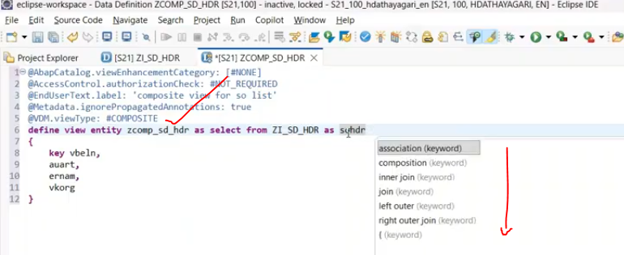
Inner JOIN or JOIN both are same
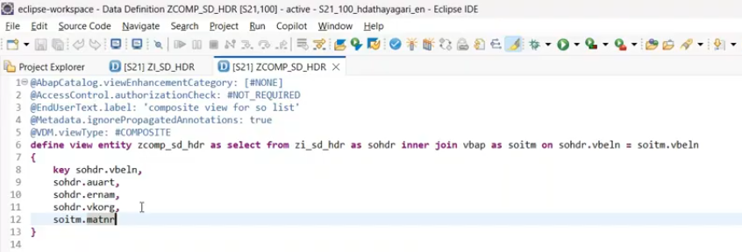
Consumption View:
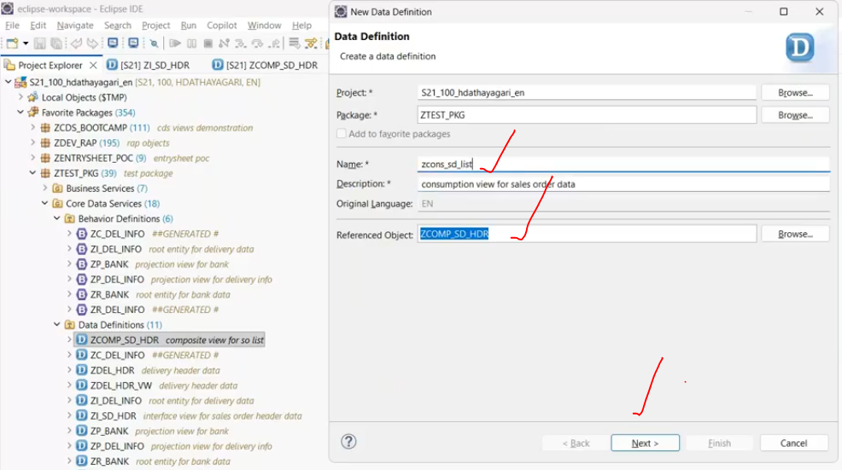
Here you can apply all the odata annotations and UI annotations.
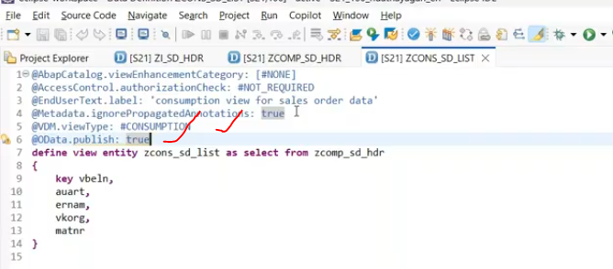
Ex:
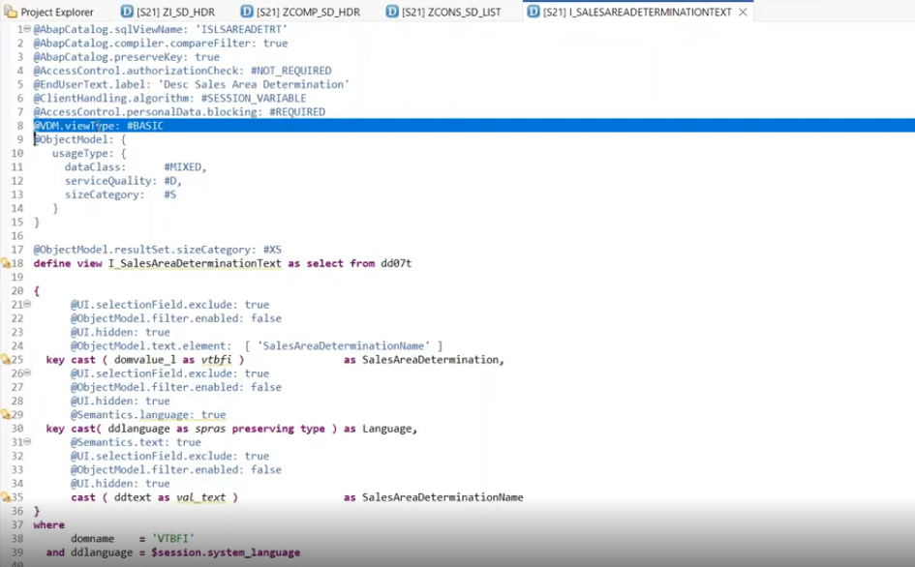
Ex: Standard #CONSUMPTION
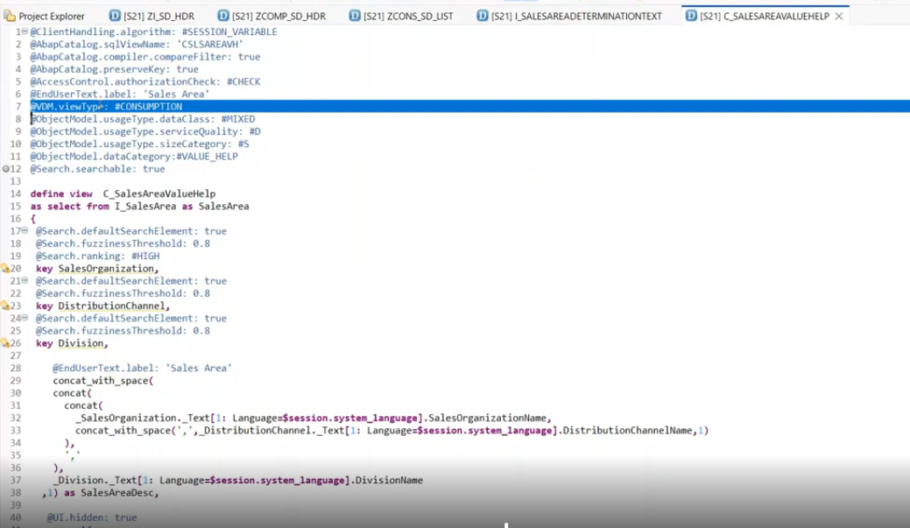

What is Virtual Elements:
Virtual elements are not stored in source data base.- these are defined runtime of the CDS view.
Ex: I have the CDS view-ZCONS_SD_LIST along with I have to consume the runtime column- that will do the some calculation finally this is append to that.
If you want to fill the single columns or two columns , you can prefer with virtual elements.
Virtual elements fields are not stored anywhere..
Ex: for every sales order or delivery order .. you will be having the header text and item text – might not be available all the texts for sales order/ delivery order.
In item text – we don’t have any standard text. But we have to show..
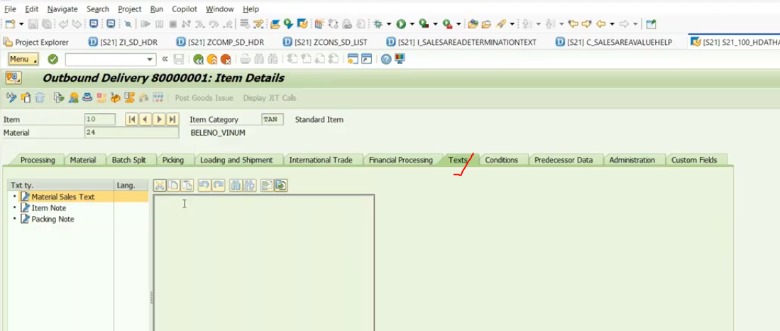
To show the particular text, we have the function module- READ_TEXT- to implement FM in the CDS directly not possible- in this case we can use it virtual elements.
Use Cases for Virtual Elements
You can use the concept of virtual elements to implement the following use cases:
- Calculating values of fields that are not part of a persistence model
- Filtering of calculated field values
- Sorting of calculated field values

Example: I have to calculate for that particular delivery header- how many number of items which are exist in that..?- show count of items in header view.
Create CDS view: ZDELV_ITM_COUNT
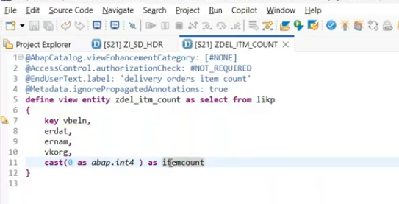
Directly what is the type of itemcount- system will not understand so we have given as CAST( 0 AS abap.int4 ) – here we are telling item count to store the int4 value.
Save and activate –
Check preview:
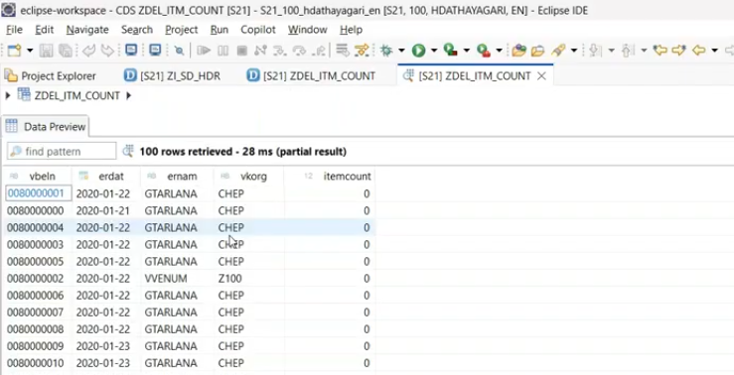
Now how to make it itemcount field as runtime field…?- to make the itemcount field as virtual element field.. we have to apply for the some annotations.
@ObjectModel.virtualElementCalculatedBy: ‘Abap:ZCL_DEL_ITM_COUNT ‘ and we need to define the class
Every runtime class can be defined using ‘ABAP:ZCL_DEL_ITM_COUNT’
Now create the class manually with the name as ZCL_DEL_ITM_COUNT and interface we will use – IF_SADL_EXT_CALC_ELEMENT_READ
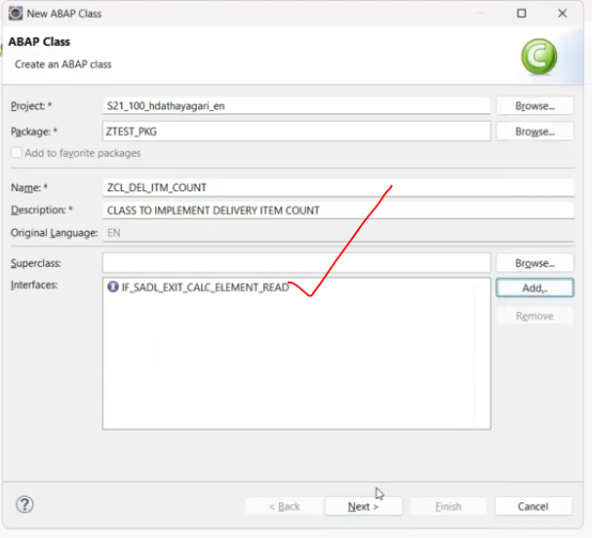
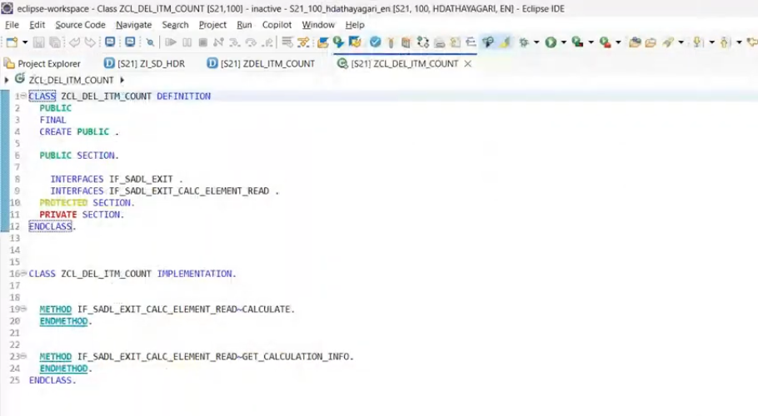
Here it generates 2 separate methods – 1- calculate method and 2. get_calculate_info.
calculate method signatures: select method press F2.
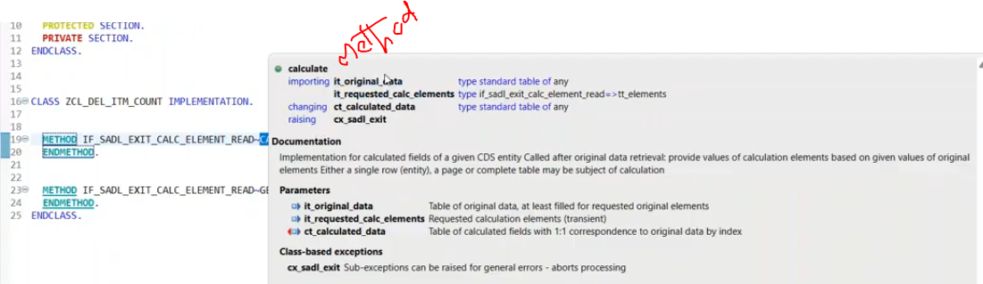
Here it _original_Data –type is cds view type and importing view data.. (Receiving data to the method )
Ct_calculated_Data – changing data- once logic has been completed- we have to send the data to cds view through this changing parameter only.
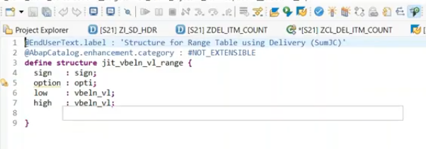
Class implementation:
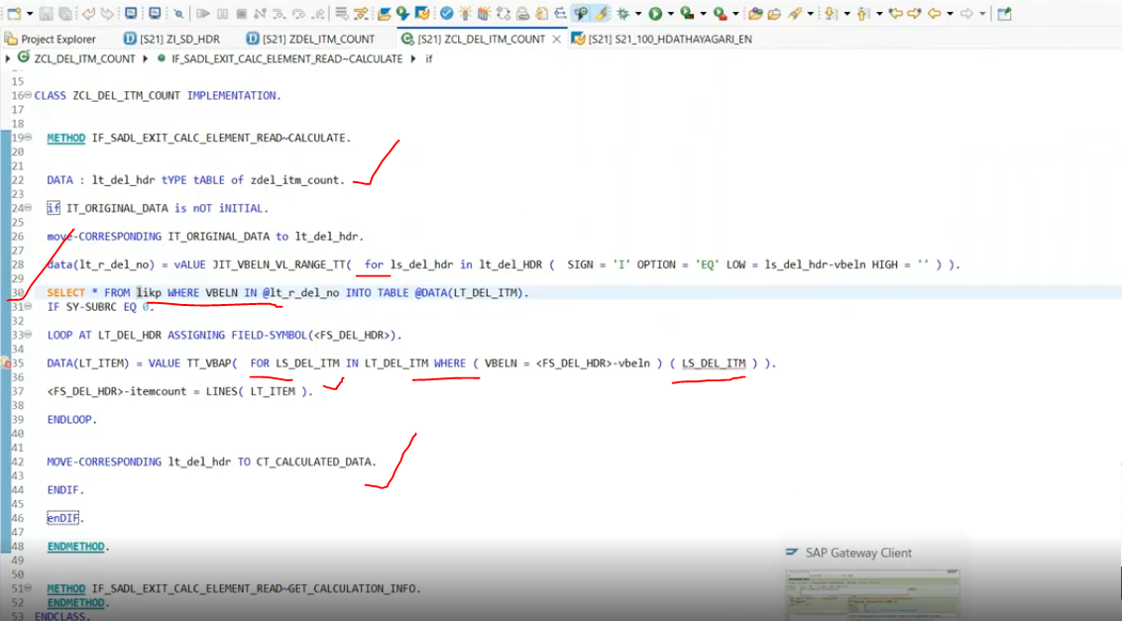
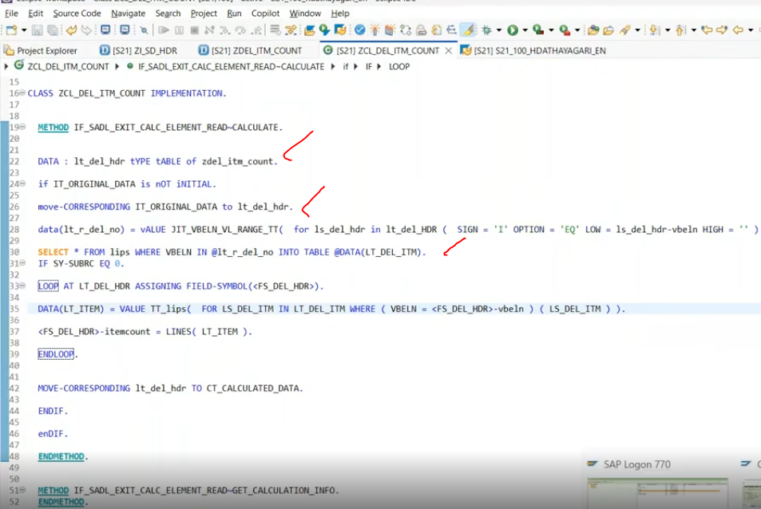
We have done the logic … but if we implemented.. but it is not populating in data preview… but this is implemented in @odata/ ui5.
Data preview still virtual element is 0.
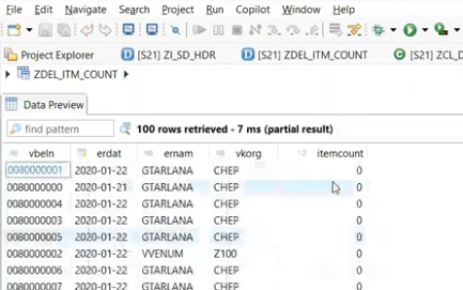
Now publish the odata service .
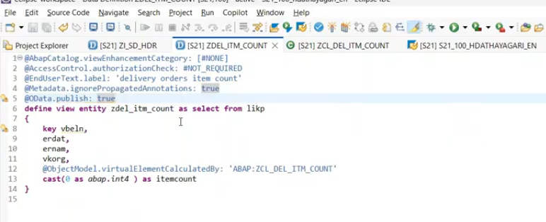
Activate.
Copy the service - <view>_cds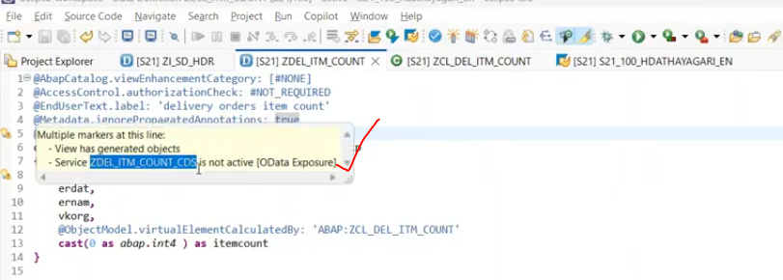
Go to the main service registration in GUI-/n/iwfnd/main_service
Now register the ZDEL_ITM_COUNT_CDS – odata service.
Now registration has completed..
Now put the breakpoint and check in the class.
Now test at Odta level- /iwfnd/gw_Client
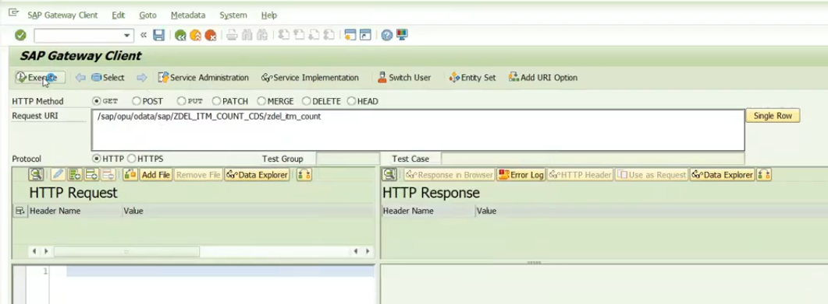
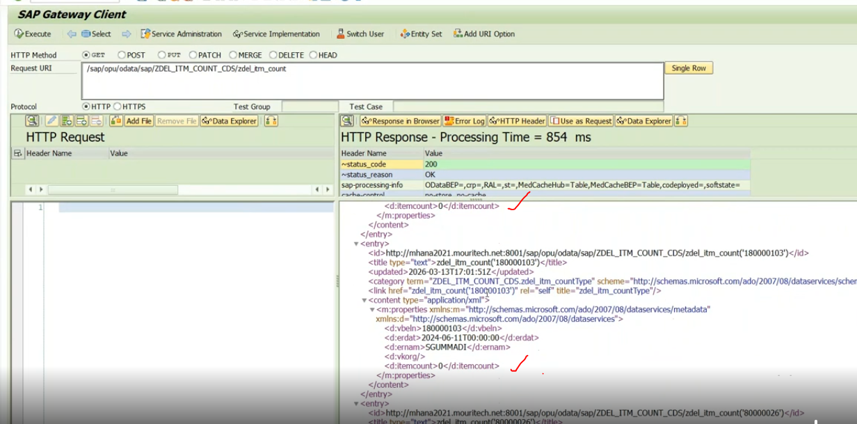
But item count still we are getting blank/ 0 only… check in debug..
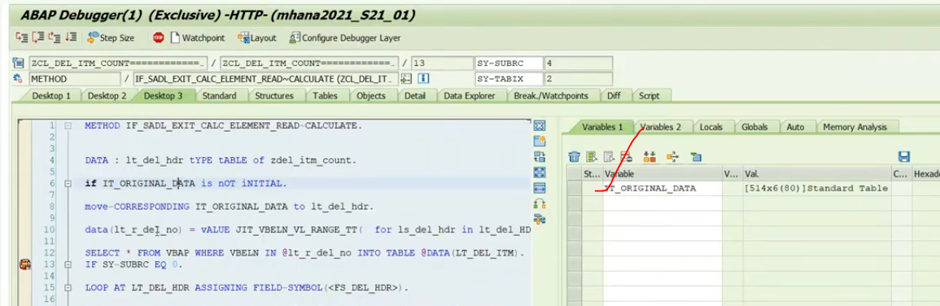
Dellivery line items are available in lips table .. we have to change the logic .. already added in previous screen..
Again execute.
CT_CALCULATED_DATA- whatever virtual elements defined … those are available..
IT_ORIGINAL_DATA- your view data..
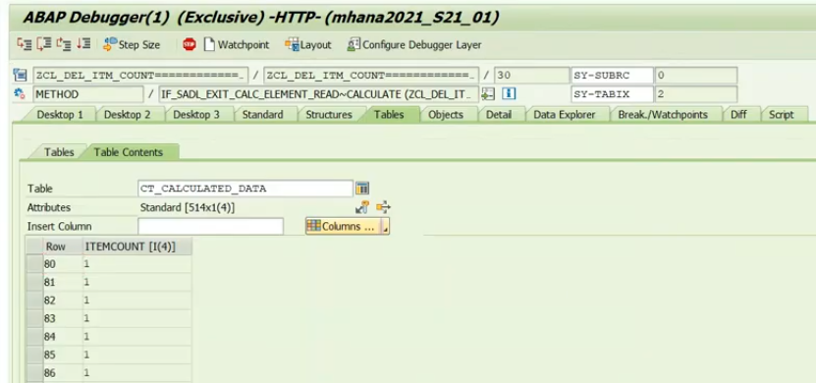
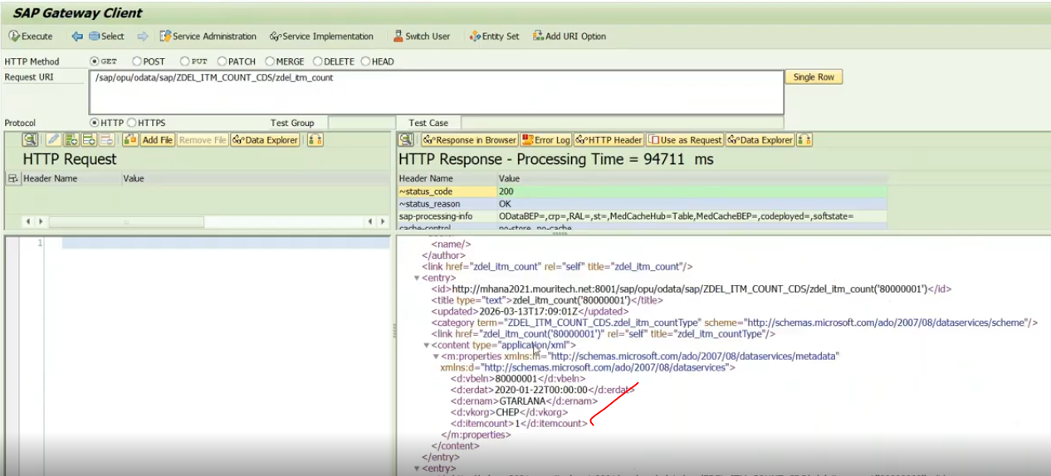
Syntaxes:
CDS annotations specific to the calculation of field values (use case 1)
define view <CdsConsumptionView>
as select from <data_source>
{
...
@ObjectModel.readOnly: true
@ObjectModel.virtualElement
@ObjectModel.virtualElementCalculatedBy: 'ABAP:<code_exit_class>'
cast( '' as <dtype> preserving type) as <view.element>
...
}
Prerequisites
The calculation of field values requires that:
- The following virtual element annotations are added to the corresponding element at the level of the CDS consumption view:
@ObjectModel.readOnly: true
@ObjectModel.virtualElement: true
@ObjectModel.virtualElementCalculatedBy: 'ABAP:<code_exit_class>'
NoteThe annotated view element must not represent a key field.
- An ABAP code exit class is created for implementing the code exit interface IF_SADL_EXIT_CALC_ELEMENT_READ.
Implementation Steps
The code exit contract for calculation of the virtual value requires the implementation of both the methods GET_CALCULATION_INFO and CALCULATE of the code exit interface IF_SADL_EXIT_CALC_ELEMENT_READ.

Example
The method GET_CALCULATION_INFO provides the list of fields required for data calculation:
- The field CONVERTEDGROSSAMOUNT saves the values of the gross amount for sales order items calculated in EUR (target currency).
- The field GROSSAMOUNTWITHDISCOUNT is used to save the calculated gross amount values under consideration of specific discount rules.
CLASS zcl_calculation_discount DEFINITION
PUBLIC
FINAL
CREATE PUBLIC .

PUBLIC SECTION.
INTERFACES:
if_sadl_exit_calc_element_read.

PROTECTED SECTION.
PRIVATE SECTION.
ENDCLASS.

CLASS zcl_calculation_discount IMPLEMENTATION.

METHOD if_sadl_exit_calc_element_read~get_calculation_info.
IF iv_entity <> 'ZDEMO_C_SORDERITEM_VF'.
RAISE EXCEPTION TYPE zcx_calc_exit EXPORTING textid = zcx_calc_exit=>entity_not_known.
ENDIF.
IF line_exists( it_requested_calc_elements[ table_line = 'GROSSAMOUNTWITHDISCOUNT' ] ).
APPEND 'CONVERTEDGROSSAMOUNT' TO et_requested_orig_elements.
ENDIF.
ENDMETHOD.

METHOD if_sadl_exit_calc_element_read~calculate.

CHECK NOT it_original_data IS INITIAL.

DATA lt_calculated_data TYPE STANDARD TABLE OF zdemo_c_sorderitem_vf WITH DEFAULT KEY.
MOVE-CORRESPONDING it_original_data TO lt_calculated_data.

LOOP AT lt_calculated_data ASSIGNING FIELD-SYMBOL(<ls_calculated_data>).
<ls_calculated_data>-grossamountwithdiscount =
COND #( WHEN <ls_calculated_data>-convertedgrossamount > '1000'
THEN 1000 + ( <ls_calculated_data>-convertedgrossamount - 1000 ) * '0.9'
ELSE <ls_calculated_data>-convertedgrossamount ).
ENDLOOP.
MOVE-CORRESPONDING lt_calculated_data TO ct_calculated_data.

ENDMETHOD.

ENDCLASS.

CDS Annotations specific to field filtering
define view <CdsConsumptionView>
as select from <data_source>
{
...
@ObjectModel.filter.transformedBy: 'ABAP:<code_exit_class>'
cast( '' as <dtype> preserving type) as <view.element>
...
}
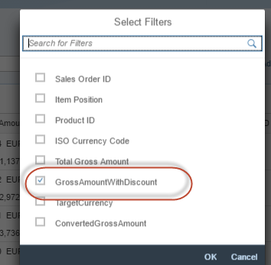
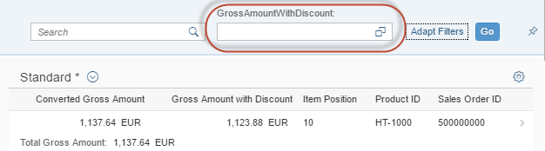
Added filter for calculated field values on the Fiori UI
Prerequisites
The filter transformation requires that:
- The following filter annotation is added to the corresponding element at the level of the CDS consumption view:
@ObjectModel.filter.transformedBy: 'ABAP:<code_exit_class>'
RememberThe annotated view element must not represent a key field.
- An ABAP class is created for implementing the code exit interface IF_SADL_EXIT_FILTER_TRANSFORM.
- Implementation Steps
- The code exit contract for filter transformation requires the implementation of the method MAP_ATOM of the code exit interface IF_SADL_EXIT_FILTER_TRANSFORM.
- Example
- The implementation of the method MAP_ATOM in the listing below demonstrates how you can transform filter conditions specified for the annotated (virtual) view element GROSSAMOUNTWITHDISCOUNT to filter criteria of other view elements. In other words, we have to replace the filter condition on the calculated field GROSSAMOUNTWITHDISCOUNT with a condition for original the persistent field CONVERTEDGROSSAMOUNT.
- Listing: Filter transformation class ZCL_FILTER_DISCOUNT
CLASS zcl_filter_discount DEFINITION
PUBLIC
FINAL
CREATE PUBLIC .

PUBLIC SECTION.
INTERFACES:
if_sadl_exit_filter_transform.
PROTECTED SECTION.
PRIVATE SECTION.
ENDCLASS.

CLASS zcl_filter_discount IMPLEMENTATION.

METHOD if_sadl_exit_filter_transform~map_atom.
IF iv_element <> 'GROSSAMOUNTWITHDISCOUNT'.
RAISE EXCEPTION TYPE zcx_filter_exit EXPORTING textid = zcx_filter_exit=>element_not_expected.
ENDIF.

DATA(lo_cfac) = cl_sadl_cond_prov_factory_pub=>create_simple_cond_factory( ).
DATA(amount) = lo_cfac->element( 'CONVERTEDGROSSAMOUNT' ).
DATA(lv_discountvalue) = 1000 + ( iv_value - 1000 ) / '0.9'.

CASE iv_operator.

WHEN if_sadl_exit_filter_transform~co_operator-equals.

ro_condition = amount->less_than( '1000' )->and( amount->equals( iv_value )
)->or( amount->greater_than( '1000' )->and( amount->equals( lv_discountvalue ) ) ).

WHEN if_sadl_exit_filter_transform~co_operator-less_than.

ro_condition = amount->less_than( '1000' )->and( amount->equals( iv_value )
)->or( amount->greater_than( '1000' )->and( amount->less_than( lv_discountvalue ) ) ).

WHEN if_sadl_exit_filter_transform~co_operator-greater_than.
ro_condition = amount->less_than( '1000' )->and( amount->equals( iv_value )
)->or( amount->greater_than( '1000' )->and( amount->greater_than( lv_discountvalue ) ) ).

WHEN if_sadl_exit_filter_transform~co_operator-is_null.
ro_condition = amount->is_null( ).

WHEN if_sadl_exit_filter_transform~co_operator-covers_pattern.
RAISE EXCEPTION TYPE zcx_filter_exit.

ENDCASE.
ENDMETHOD.

CDS Annotations specific to field Sorting
define view <CdsConsumptionView>
as select from <data_source>
{
...
@ObjectModel.sort.transformedBy: 'ABAP:<code_exit_class>'
cast( '' as <dtype> preserving type) as <view.element>
...
}
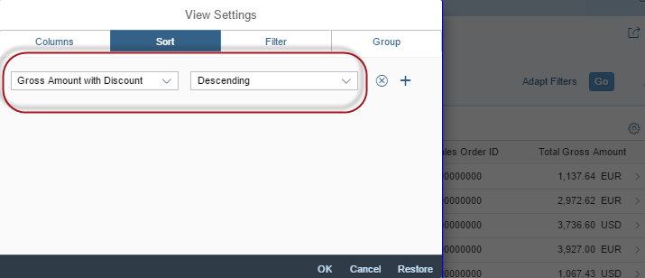
Settings for sorting based on the calculated field 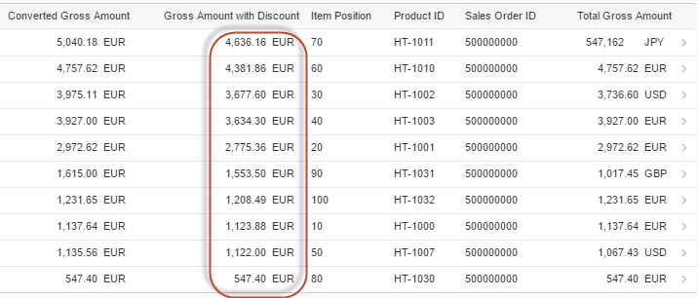
Sorting calculated field values on the Fiori UI
Prerequisites
The sorting of field values requires that:
- The following sort annotation is added to the corresponding element at the level of the CDS consumption view:
@ObjectModel.sort.transformedBy: 'ABAP:<code_exit_class>'
- RememberThe annotated view element must not represent a key field.
- An ABAP class is created for implementing the code exit interface IF_SADL_EXIT_SORT_TRANSFORM.
- Implementation Steps
- The code exit contract for sort transformation requires the implementation of the method MAP_ELEMENT of the code exit interface IF_SADL_EXIT_SORT_TRANSFORM. For further information, see: Interface IF_SADL_EXIT_SORT_TRANSFORM
CLASS zcl_sort_discount DEFINITION
PUBLIC
FINAL
CREATE PUBLIC .

PUBLIC SECTION.
INTERFACES:
if_sadl_exit_sort_transform.
PROTECTED SECTION.
PRIVATE SECTION.
ENDCLASS.

CLASS zcl_sort_discount IMPLEMENTATION.

METHOD if_sadl_exit_sort_transform~map_element.
IF iv_element <> 'GROSSAMOUNTWITHDISCOUNT'.
RAISE EXCEPTION TYPE zcx_sorting_exit EXPORTING textid = zcx_sorting_exit=>element_not_expected.
ENDIF.
APPEND value #( name = `CONVERTEDGROSSAMOUNT` ) TO et_sort_elements.
ENDMETHOD.

ENDCLASS.

https://help.sap.com/docs/SAP_NETWEAVER_AS_ABAP_751_IP/cc0c305d2fab47bd808adcad3ca7ee9d/04e64a8ffffe49b8a8a5469796f397c0.html?version=7.51.7

Creating Application-Specific Exception Classes
To handle application-specific exceptions in the context of virtual elements, you must create exception classes that inherit from the generic SADL exit class CX_SADL_EXIT.
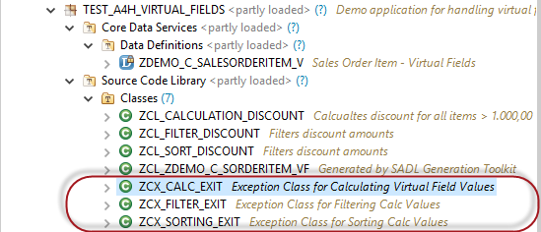
Exception classes for specific use cases
To explicitly raise a predefined exception, add, for example, the constant element_not_expected to the exception class – as shown in the listing below.
Listing: Added constant element_not_expected
CLASS zcx_filter_exit DEFINITION
PUBLIC
INHERITING FROM cx_sadl_exit
FINAL
CREATE PUBLIC .

PUBLIC SECTION.

CONSTANTS:
BEGIN OF element_not_expected,
msgid TYPE symsgid VALUE '<MY_MESSAGE_ID>',
msgno TYPE symsgno VALUE '<MY_MESSAGE_NR>',
attr1 TYPE scx_attrname VALUE '<ATTR1>',
attr2 TYPE scx_attrname VALUE '<ATTR2>',
attr3 TYPE scx_attrname VALUE '',
attr4 TYPE scx_attrname VALUE '',
END OF element_not_expected .

INTERFACES if_t100_dyn_msg .
INTERFACES if_t100_message .

METHODS constructor
IMPORTING
!textid LIKE if_t100_message=>t100key OPTIONAL
!previous LIKE previous OPTIONAL .
PROTECTED SECTION.
PRIVATE SECTION.
ENDCLASS.

CLASS zcx_filter_exit IMPLEMENTATION.

METHOD constructor ##ADT_SUPPRESS_GENERATION.
CALL METHOD super->constructor
EXPORTING
previous = previous.
CLEAR me->textid.

IF textid IS INITIAL.
if_t100_message~t100key = if_t100_message=>default_textid.
ELSE.
if_t100_message~t100key = textid.
ENDIF.
ENDMETHOD.
ENDCLASS.
Annotations for Text- and Fuzzy Search
First of all, you need the following CDS annotation at the view level:
Annotation and Value | Effect
@Search.searchable: true/false | Defines whether a CDS view is generally relevant for search scenarios. This annotation provides a general switch and a means to quickly detect whether a view is search-relevant or not. Set to value true in order to enable search support by means of @Search annotations. Here, at least one view field must be defined as @defaultSearchElement at element level.

